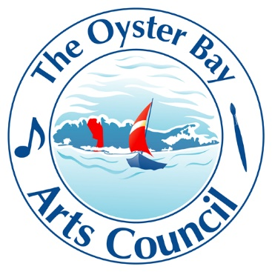

The Oyster Bay Arts Council

169 Ocean Avenue, Massapequa, N.Y. 11758

516-225-5363

NO EMAILS ARE SHARED OR SOLD TO ANY OTHER ENTITY. YOUR CONTACT INFORMATION IS PRIVATE UNLESS YOU WISH TO HAVE IT PUBLISED IN THE TOBAC NEWSLETTER!

When you join The Oyster Bay Arts Council you will be placed on a Preferred Email List. You will be advised as to what scholarships and subsidies The Oyster Bay Arts Council will give during the year.

____ $35.00 | Participating business membership
At this level of membership, you will receive the password to view and download the quarterly art council listing calendar and your business will be placed on our resource guide. Please note that the resource guide is currently being revised.

____ $20.00 | Individual Membership
At this membership point, you will receive the password to view and download the quarterly News Calendar. You will receive a report on scholarships and programs that The Oyster Bay Arts Council is planning to do.

Sponsorships are available at the following donation points:
You will be acknowledged at all of our events and included in social media campaigns. You can opt out and be anonymous is so desired. You will receive a letter of appreciation on your generous donation.
____ $250.00 | Bronze Contributor

____ $500.00 | Silver Contributor

____ $1,000.00 | Gold Contributor

____ $2,000.00 | Platinum Contributor

TOBAC will respect the wishes of Anonymous. All donations are IRS exempt. TOBAC is a 501c charitable organization. Every dollar received is planned to assist the arts and the artists who take part in aesthetic endeavors.

Please go to the donation button in the main menu.
Any questions? Email our Treasurer Lawrence Spiro larryspiro@aol.com 516-655-8780 c

